**Project Name: Online Employee Information System**

Develop a web based application “Employee Information System”. The user of the system is admin and Employee.

Admin tasks are given below:

|  |  |
| --- | --- |
| **Tasks** | Login to the system with user name and password. |
| Create a new account/profile for the new employee by providing some information like employee id, name, designation etc. |
| Update the employee information. |
| Delete an employee record from the database. |

Employee tasks are given below:

|  |  |
| --- | --- |
| **Tasks** | Login to the system with user name and password. |
| View his/her profile. |

Following are the details of each task:

**Task 1**

There should be a table “Admin” to store Admin details (such as name, id, password, emailid, contact). Detail of table is as follow:

|  |  |
| --- | --- |
| **Column Name** | **Data Type** |
| Id [primary key] | Integer |
| Name | Varchar(50) |
| Password | Varchar(50) |
| Emailid | Varchar(100) |
| Contact | Varchar(100) |

When trying to log in, the system shall check for correct id and password. If incorrectly entered by the user, system shall show error message.

**Task 2**

1. There should be a table “Employee” to store the employee details (such as name, id, password, emailid, contact). Detail of table is as follow:
2. The columns and data types of these columns shall be:

**Employee**

|  |  |
| --- | --- |
| **Column Name** | **Data Type** |
| Employee_id [primary key] | Integer |
| Name | Varchar(50) |
| Password | Varchar(50) |
| Designation | Varchar(100) |
| Contact | Varchar(100) |

**Task 3**

You have to design the main interface as per the following sample screen shot.

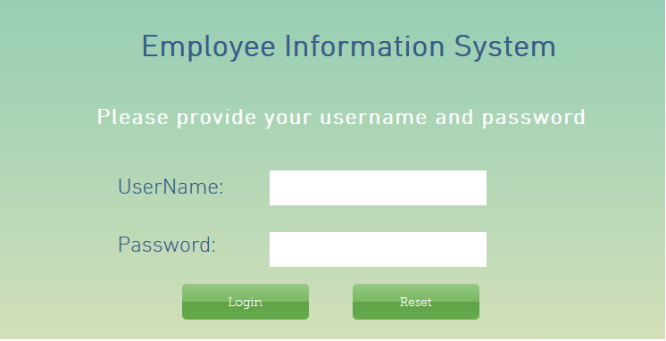

**Task 4**

If the login user is a dmin, then the following sample screen will appear :

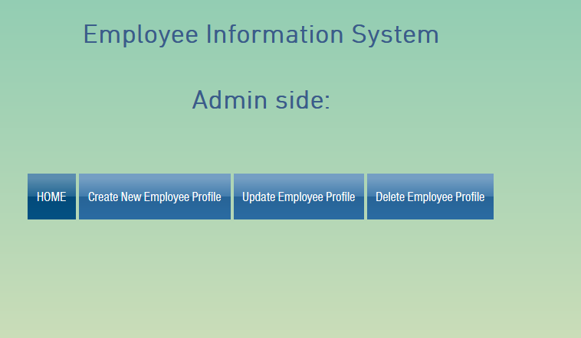

**Task 5**

The admin will create a profile for new employee by clicking on the “Create New Employee Profile”.

You have to deisgn the interface for “Create New Employee Profile” as per the following sample :

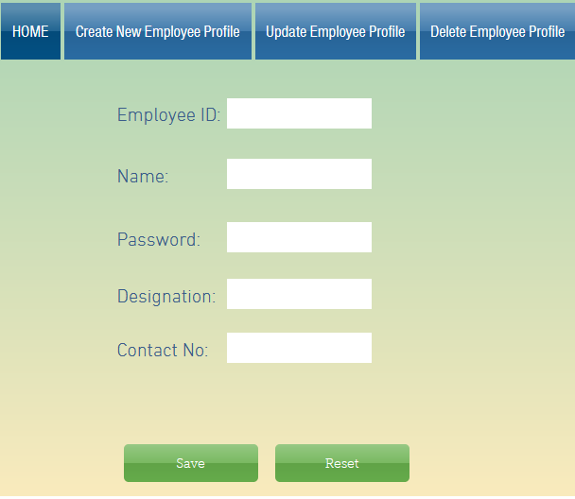

**Task 6**

Admin can update an employee profile by clicking on “Update Employee Profile”. The sample interface is given below:

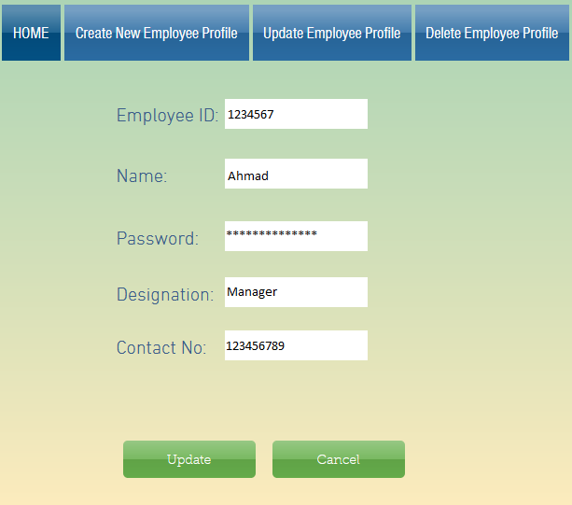

**Task 7**

Admin should delete an employee profile by clicking on “Delete Employee Profile”. The sample interface is given below:

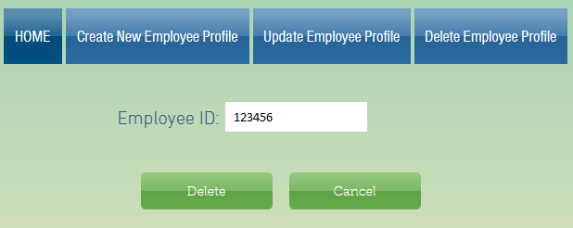

When admin click on the “Delete” button, then a message should display that “The employe profile has been deleted”.

**Task 8**

When the login user is an employee, then the following sample interface will appear, and his/her profile details will be displayed as describe in the following sample interaface.

